**Shipping freight is paid up to truck food (without stairs or other architectural barriers).**

**In order to quote the handling, placement and anchorage charge, the information provided in this form will be taken into account.**

**Please fill out the form below, making sure the information is correct. Otherwise, there may be an additional charge.**

**VEHICLES ACCESS**

Delivery will be carried out with type 2 trucks with payload of 3,500 kgs (6 meter box)

* Is there a parking area for this type of vehicle? (mark with a circle) YES NO
* Are there any traffic restrictions on this type of vehicle? YES NO
* Please provide a brief description of the access

...............................................................................

...............................................................................

...............................................................................

.........................................................................

**PRODUCT DELIVERY DETAILS**

Contrast the information on the type of stairs, elevator, etc., with the diagrams on page 2.

**It is very important that the information you provide is correct**.

1. *BUILDING ACCESS*

Are there any steps at the entrance of the building? YES NO

If so, how many? ………….

Is there any access ramp? YES NO

2. *INSTALLATION ON THE FLOOR*

Indicate the number of floors to go up or down  
You will have to…. GO UPSTAIRS DOWNSTAIRS (mark with a circle)

Delivery will be made by (mark with a circle)  
ELEVATOR STAIRCASE WINDOW-BALCONY

## 2.1 *DELIVERY BY ELEVATOR*

## Please indicate the following parameters:

## Elevator’s door height (g) ………. cm

## Elevator’s door width (f) ………. Cm

## Inside’s elevator width (i) ………. Cm

## Inside’s elevator height (h) ………. Cm

## Inside’s elevator depth (j) ………. Cm

## Maximum load …………………….kg

2.2 *DELIVERY BY STAIRCASE*

Total number of stairs? ….

What material the stairs are made of? (made of masonry, wood, metal, etc) …….

Are the stairs coated? YES NO (IN THE AFFIRMATIVE CASE, PLS. INDICATE THE TYPE OF COATING) ………………………………………………..

* STAIRCASE’S LANDINGS

Indicate the diagram nº of your stairs (from 1 to 4) …. Number of landings ……….

Number of stairs per landing ……

* CONTINUOUS STAIRS

Indicate the diagram nº of your stairs (from 5 to 7) ……

Total number of stairs per floor ….

Are they spiral stairs? YES NO

* STAIRS DIMENSIONS

Step’s height (a) ………….

Step’s width (b) ………….

Step’s depth © ………….

Landing’s width (d) ……….

Landing’s depth (e) ………

* DOORS DIMENSIONS

Is there any door on the way? YES NO

Indicate the smallest door’s dimensions:

Door’s width ……..

Door’s height ……..

Lowest roof’s height to be found on the way ……..

3. *SAFE OR CABINET ANCHORAGE*

Is the anchorage service needed YES NO

Anchorage place:

FLOOR WALL BOTH

(for certified safes the anchorage is only on the floor)

Need of the anchorage certificate according to UNE 108136 YES NO

Anchorage by means of the fixing plate (mod. AP0E)?

YES NO

***Please confirm that where the safe is to be anchored is free of pipes, cables, etc.***

# Name and Signature





Date

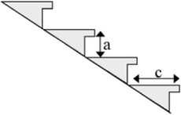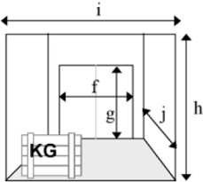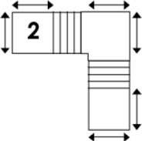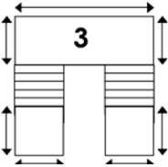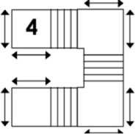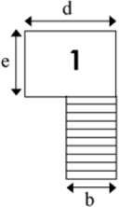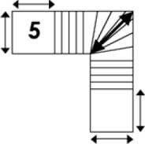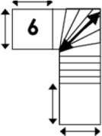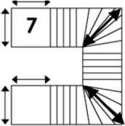

STAIRCASE WITH LANDINGS DIAGRAMS

CONTINUOUS STAIRS DIAGRAMS Dimensions:

a) Step’s height

1. Step’s Depth
2. Landing’s width
3. Landing’s depth
4. Lift door’s width
5. Lift door’s height
6. Inside lift height
7. Inside lift width
8. Inside lift depth



**Delivery details**

Distributor details Name:………………………………………………..…….

Contact name:………………………………. Telf……………………….

Customer details Name:………………………………………………………..

Contact name:……………………………………….. Telf:………………………. Delivery address:…………………………………………………………….

Delivery city:……………………………………………………………….

Product details: Model:………………………………………………………………………….

Dimensions:…………………………..cm (height*width*depth) Weight kg

Quantity:…………………………..

**Installer’s details** (To be fill out by Arcas Ollé, S.L.)

Installer: Name:………………………………………………..…….

Amount of the Service provided::……………………………………….. Site visit: YES NO

***Installer (signature and date)***